**Multi-Class Classification:**

Multi-Classification works by using multiple binary classifications. It looks at all the combinations of the target feature e.g. if we wanted to compare apples, oranges, and mangos it would develop binary classifications for apples vs oranges and mangos, oranges vs apples and mangos, and mangos vs apples and oranges. It would then return the target value that scored the highest on all the tests.

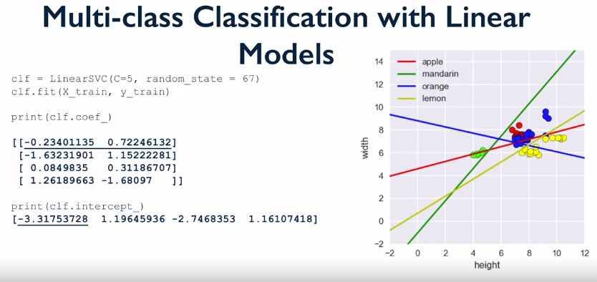

Not that now we get an 2d array of coefficients as Scikit-learn is actually creating 4 different models for all the combinations (e.g. apples vs not apples).